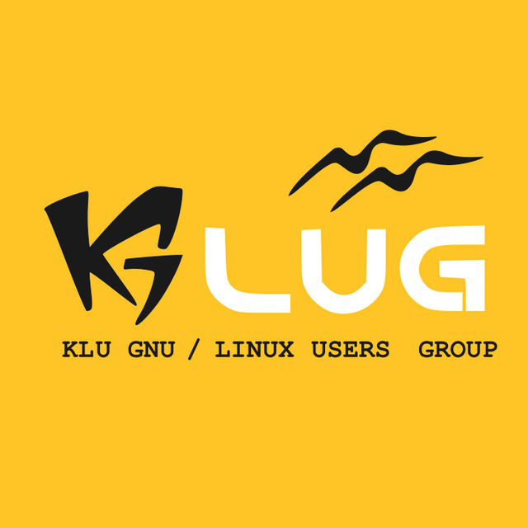

KLU GLUG MEET ON 13-09-2017

Session on Drupal :

Drupal is content management software. It's used to make many of the websites and applications you use every day. Drupal has great standard features, like easy content authoring, reliable performance, and excellent security. But what sets it apart is its flexibility; modularity is one of its core principles. Its tools help you build the versatile, structured content that dynamic web experiences need.
It's also a great choice for creating integrated digital frameworks. You can extend it with any one, or many, of thousands of add-ons. Modules expand Drupal's functionality. Themes let you customize your content's presentation. Distributions are packaged Drupal bundles you can use as starter-kits. Mix and match these components to enhance Drupal's core abilities. Or, integrate Drupal with external services and other applications in your infrastructure. No other content management software is this powerful and scalable.

Session by:- Raghav Reddy and Rahul Chagarlamudi

Students Attended:-
40 students attended the session on Drupal.

Classroom/Venue:- C109
